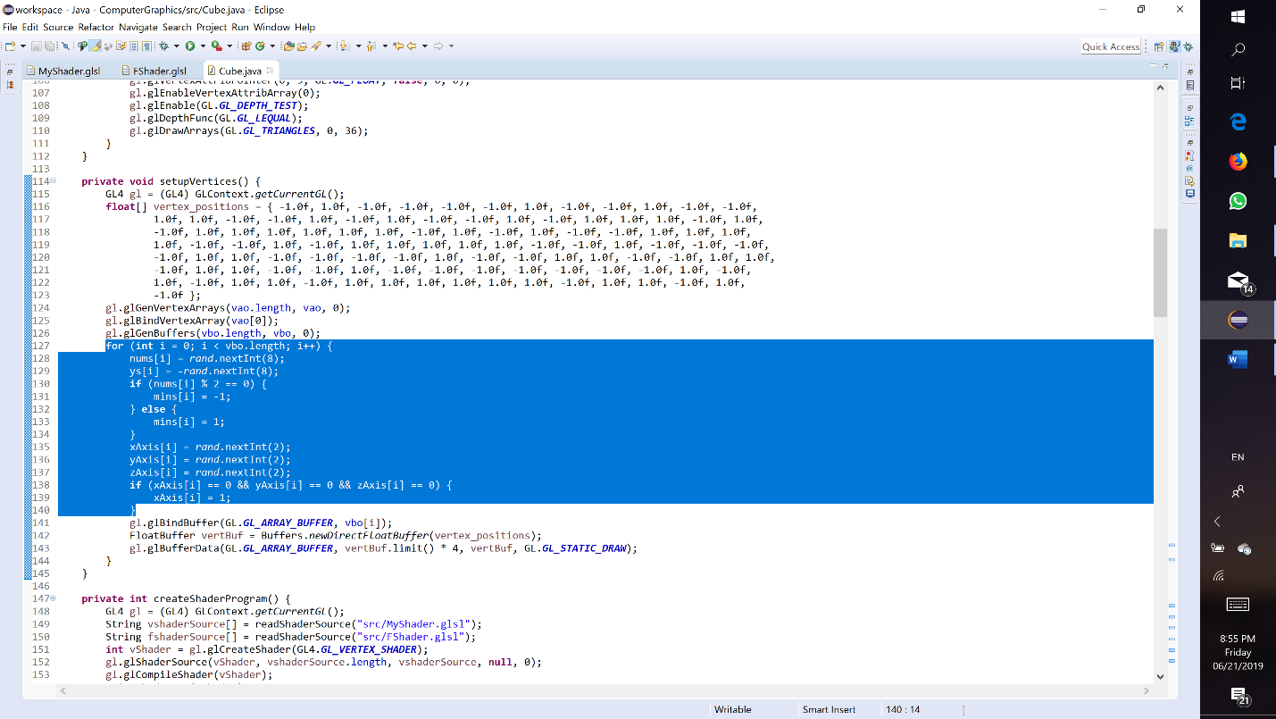

I would like to explain this part. As you can see, I created a for loop and set the size of array vbo to 10 and I sent the same cube to the buffer. I got the idea from the part in textbook with cube and pyramid. I think it was the easiest way of creating several cubes, although it is hard coding. The arrays nums and mins are used for random translations of cubes. X, Y, ZAxis arrays are used for random rotations. 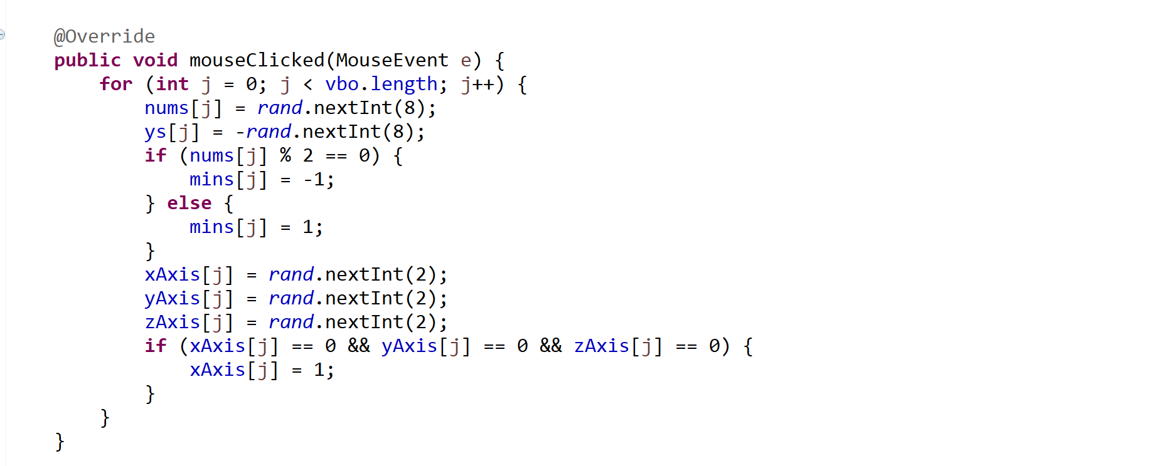

Also, this part is for changing the locations of the existing cubes by clicking the mouse. I could not make the cubes appear on the chosen location by clicking.